General VCMap Notes

Overall Structure of the Program via Pictures and a Few Notes:

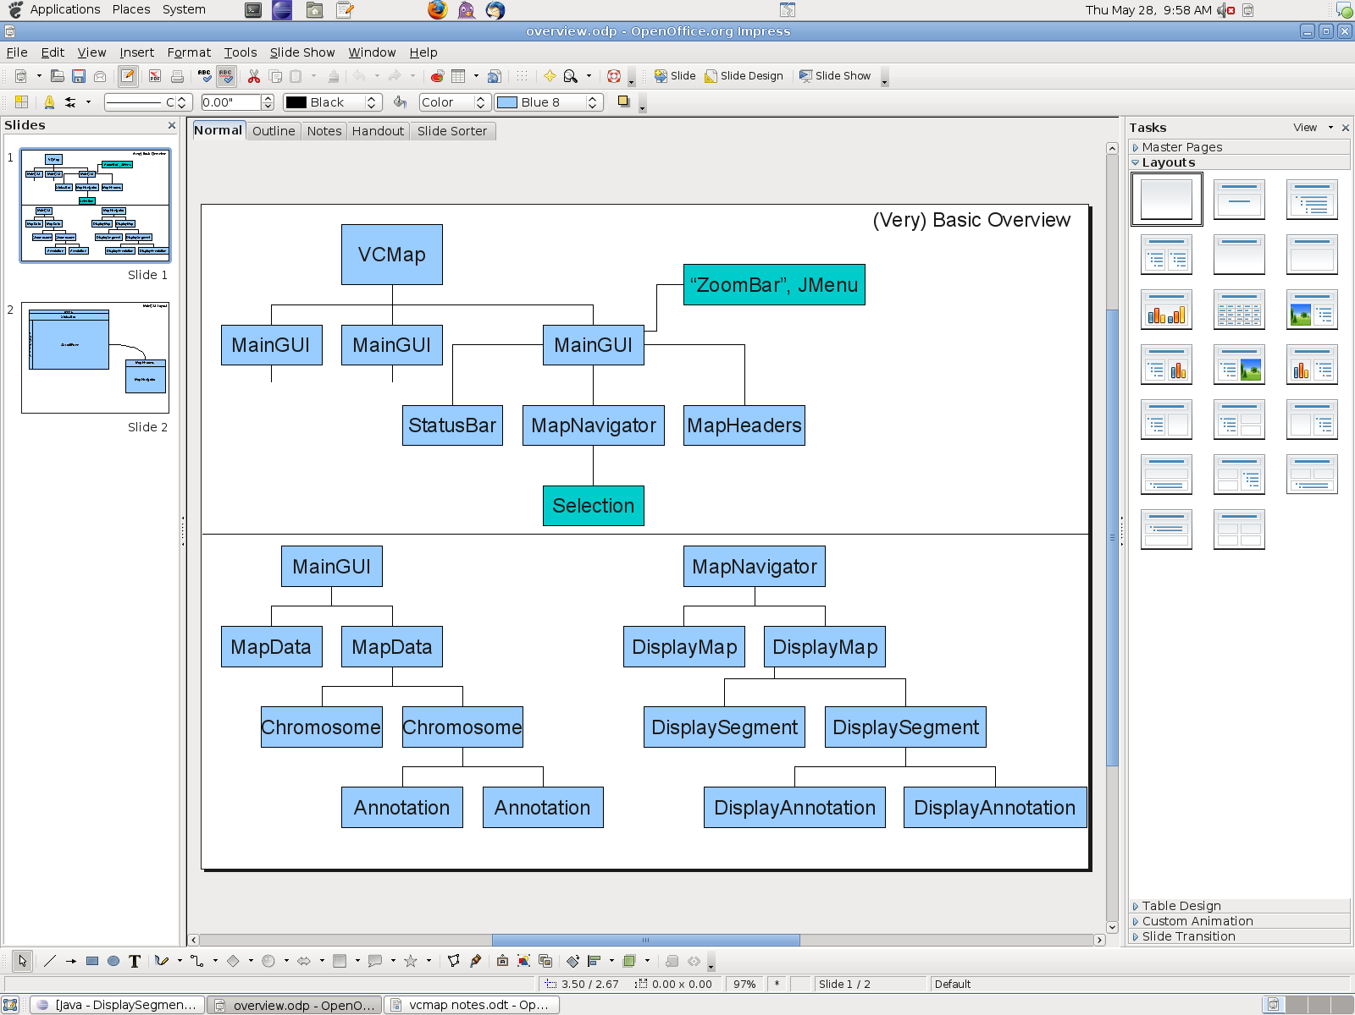
- Each “Display” object has a reference to the data it represents visually.
- DisplaySegment is a portion of the chromosome. The portion of the chromosome that the display segment represents is determined by the SyntenyBlock it is associated with.
- Each DisplaySegment has a number of UnitLabel objects saved in it. UnitLabels represent the the unit labels (cryptic name huh?) displayed on the right side of the display segment.
- DisplayAnnotation can store one or more Annotation. There is more than one annotation when there is not enough room in a particular area to display all the annotation.
- You are going to spend a lot of time in the MapNavigator
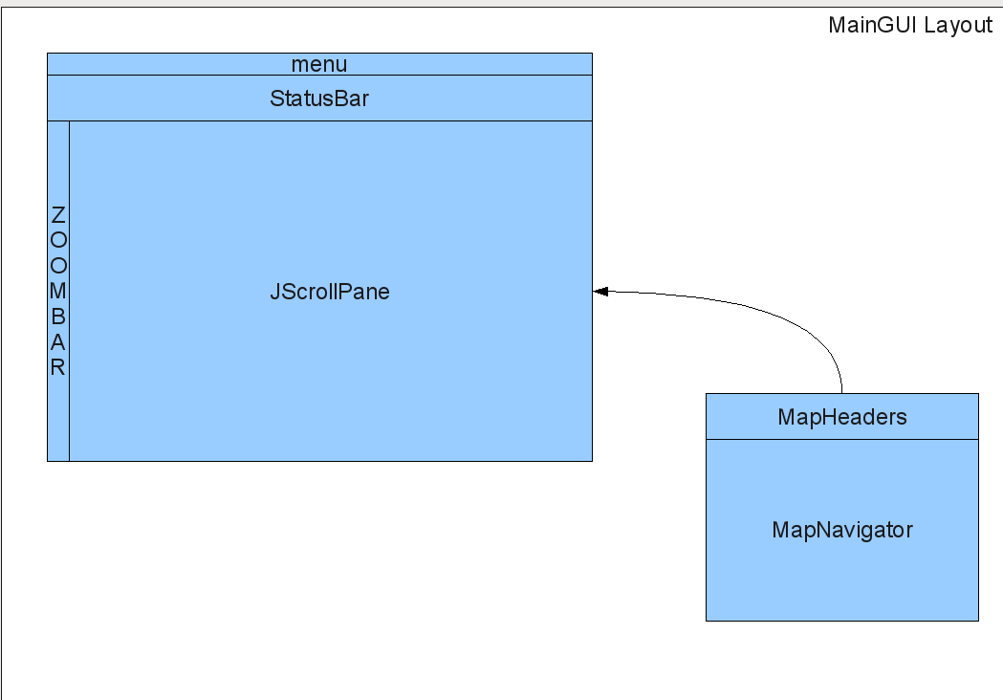

How genetic data of the memory model is set up...

Data | Display
Annotation | DisplayAnnotation
Chromosome | DisplaySegment
MapData | DisplayMap

How the selection model is set up...

Selecting a piece of annotation (Single click on a piece of annotation, click and drag an “interval over the annotation names or select the annotation in the Search dialog)
- Selects the annotation
- Selects all the sibling annotation
- Selects the associated map
- Creates a selection interval

Select a display segment (single click on a segment)
- Selects the segment
- Selects the associated map

Create a selection interval (Click on a segment and drag)
- Creates corresponding selection intervals (if multiple maps)

Select a Map (Click on the map title)
- Selects the map

Note: You can select multiple segments and annotation by holding CTRL, SHIFT or COMMAND (Mac only) while selecting. You can create mutliple selection intervals in a similar fashion.

Note About Dialogs

All the dialogs were designed based on the singleton design pattern. However, because of the inability to change the parent of a JDialog, we have one instance of each dialog per instance of MainGUI.

Where to start...

To understand how a map is loaded and displayed... Start in the MapDialog class, in the actionPerformed(ActionEvent ae) method.

To understand how annotation is loaded and displayed... Start in the AnnotationDialog class, in the actionPerformed(ActionEvent) method.

To understand how the selection model works... Start in the MapNavigator class, and take a look at the mousePressed(), mouseDragged(), and the mouseReleased() methods.

Class/Method Notes

This section talks about some of the confusing/complex parts of the application. I've tried to be as thorough as possible with the comments in the code itself too...

Class: MapNavigator

Notes:
Each annotation label has a border put around it with “selectionBoxSpacing” width/height.
+------------------+
|annotationLabel|
+------------------+

The MapNavigator's width and height are calculated everytime the zoom level changes, a map new map is added, a map is shown/hidden, annotation is loaded, annotation is shown/hidden, and a user resizes the MainGUI window. The width is calculated via the “determineWidth()” method, but the height does not have a helper method. The height is calculated based on the MapNavigator's height and the zoom level set by the zoom bar. The variables “footerHeight” and “headerHeight” help ensure there is a top and bottom border in the MapNavigator.

*.isMetaDown() is used so Mac users can use the Command-key instead of CTRL or ALT.

Method: setZoomLevel(double)

Notes:
This resizes the MapNavigator and changes where the viewport is positioned depending on what is currently selected and if the user double clicked in a white space to zoom in. White space is literally the white space in the MapNavigator that does not represent any information.

Method: centerOnAnnotation(Annotation annotation)

Notes:
This method is not used at all. It has been left in the code that ideally in the future when a user selected annotation in the SearchDialog, the MapNavigator will center on the annotation.

Method: prepareDisplayMap(DisplayMap displayMap)

Notes:
There is a lock that is shared between this method and the AnnotationLoader in the AnnotationDialog and the MapLoader in the MapDialog. This lock avoids concurrent modification by the threads.

This method calls all the appropriate methods to group all the features and create all the units that are displayed. If you are planning on changing any parts of this method, you should make sure you have a good understanding of what affects your changes will have on the methods: shrinkFeatureGap(), deteremineFeatureGap(), and determineDrawnUnits(). Be sure you know how the classes: DisplayAnnotation, UnitLabel and the inner class FeatureGap work.

How feature grouping works:
Each type for each segment is treated as a seperate case. In the next iteration, it may be a good idea (and much more complex) to group all the features of a display map at once to avoid overlapping annotation between annotation of small segments that are in close proximity of one another. The method tries to sort the annotation one column at a time and forces gaps for the last column to ensure there is no overlapping connecting line to the annotation. The code is very heavily documented, so be sure to read through it slowly and carefully.

How unit labels work:
Start and stop labels are determined for each segment and then the inner labels are determined. After determining the units for all segments of a map, the unit labels are shifted up or down to avoid overlap.

It is interesting to note that the labels for the feature columns are limited in width by a constant, while the labels for the units column can change from display map to display map. More interestingly is that because the units label column can vary in size, there is a slow down when there are many more unit labels because it has to calculate the stringWidth() for every unit label at once, not as it is needed, like the feature labels.

Method: paintComponent(Graphics g)

Notes:
All the display maps must be passed through prepareDisplayMap() method before changes in preferences, hidden/shown annotations and other changes will be displayed

It is important to note that annotation is "visited" twice when being drawn in order to insure that selected annotation is drawn on top. :( This should be “fixed” at some point.

The section where the overlap box is drawn is probably the MOST CONFUSING/COMPLEX part of this whole method. The main parts of the box are drawn first and then, depending on whether annotation is selected or if you user is hoving over a piece of annotation the overlap box width changes and how each column is drawn changes. To avoid overlap boxes getting to wide there is a threshold variable that is set in the Defaults class. If there are equal or more columns to the threshold number than columns are grouped together and drawn on top of one another. If columns are grouped, it is important to note that if a column contains annotation that is selected or there is a piece of annotation that the user is hovering over, those columns containing that annotation are drawn in their own column.

Method: setTitleDragPoint(Integer titleDragPoint)

Notes:
This method is called by the MapHeaders object's mouse events to update where to draw the “dragged display map” and the method determines when to move a map to a new position. This method has been around for a while, and could probably use some reworking.

Class: MapNavigator.OverlapBox

Method: resizeMapNavigator()

Notes:
Resizes the MapNavigator when the overlap box becomes too tall for the viewport.

Method: repaint()

Notes:
Use this method when you only need to repaint the area the overlap box affects in the MapNavigator.

Class: DisplaySegment

Notes: There are two ways to get display annotation for a display segment. You can get all the display annotation at once or you can get display annotation based on the display annotation's label y-coordinate

Class: StatusBar

Notes:
This has all of the code that handles the glass pane for the MainGUI. It is important to note that the MapHeaders class actually calls this to display the types of QTL loaded using the showLoadedQTL(MouseEvent e, int xPos) method. Please read the glass pane section carefully, it is a little weird how it redistributes mouse events.

Method: updateStatusBar()

Notes:
You have to manually call this method to show any updates in the selection.

Class: Selection

Notes:
This class keeps track of everything that is selected by the user via the MapNavigator or the SearchDialog (these two classes happen to be the only classes that interact with the selection). It is important to use the method carefully in this class when it comes to selecting just a single annotation or when you are going to selecting many pieces of annotation. It is important to use the appropriate methods (in the proper order) because of the overhead involved with ensuring siblings are connected, finding what annotation belongs to which segment, creating intervals. Please read this class over very carefully to avoid some major slow downs in the future.

Method: private void verifyIntervals(String intervalType)

Notes:
This where all the intervals are merged together. There are two types of intervals, parent intervals and children intervals. Parent intervals are those drawn by the user or created by the user selecting annotation. Children intervals are those intervals corresponding to the respective parent interval. Since this method treats children and parent intervals seperately in most cases, there is still a chance of intervals overlapping.

Method: addAllAnnotation(DisplaySegment segment, Vector<Annotation> annotation)

Notes:
Please, for the love of Pete, use this method when adding a large amount of annotation. It creates the appropriate intervals and goes much much faster than calling addAnnotation(DisplaySegment segment, Annotation annotation) for each annotation.

Method: contains(DisplaySegment segment)

Notes:
This returns if annotation for this segment is in the Selection, not whether a particular DisplaySegment is selected. You have to use getSegments() to determine that.

Method: createCorrespondingIntervals(SelectionInterval interval)

Notes:
Creates the intervals the correspond to a piece of annotation. There is a potential slow down here as it searches for the appropriate display segment for a piece of annotation.

Class: SelectionInterval

Note:
SelectionInterval keeps track of all the variables needed to display an interval on a display segment and keep track of what intervals correspond to each other. SelectionInterval is designed to work with only one DisplaySegment at a time. This was done to simplify interval drawing and to ensure that intervals resized correctly during zooming.

Class: VCMap

Notes:
VCMap keeps track of all the open windows the user can interact with. VCMap is not exited until all the open windows are closed.

Method: swapBackbone(final MainGUI srcMainGUI, final MapData newBBMap, final String chromosome)

Notes:
This reloads all the map data for a new instance of MainGUI to avoid problems that occur with multiple windows.

Class: SearchDialog

The variable “lslEnabled” is used when updating the search results to avoid any slow downs caused by the list listener.

Method: searchByName(DisplayMap displayMap, String inputText)

Notes:
This method only searches for matches with the currently displayed name for annotation on the displayed (visible) display maps.

Class: Defaults

Note:
This is where all the default colors, widths, heights and other values are stored. If you want to change something's color, size, etc this is good place to start.

To see any changes to the Defaults class you either need to change the version of VCMap (Steve is in charge of that, so don't do that, unless you're Steve) or you can open the Preferences Dialog and select “Restore Defaults”.

Class: PreferencesDialog

Notes:
When this dialog is opened, it clones the current preferences immediatately. That way the user can "cancel" their changes with out us storing all the changes the user makes. The dialog also uses the variable "borderWidth" to keep all of the panels in the dialog the same width. I can't quite recall why I did this, but i remember is was a solution to some sizing problems between the different panels.

All instances of MainGUI “share” the same instance of GlobalOptions except when a user is using this dialog. This is so that changes in the preferences dialog can be shown only in one window, so the user could compare the preference changes and to keep the changes from taking to long to be applied.

Class: DetailsDialog

Note:
In order to save memory and simplify code, the tabbed pane in this dialog only has one panel that all the tabs share. View the constructor of this class to see how this is achieved.

Class: GlobalOptions

Method: isShown(String featureType) & getColor(String type)

Note:
The parameters for these methods are NOT case sensitive!

Changes I'd make/Things to think about with VCMap 2.0

- Better feature grouping and creation of unit labels is key. There is a major slow down with this process and it should be enhanced. How? Well, I don't know. We probably need to make better use of the Selection, DisplayAnnotation, DisplaySegment, and DisplayMap classes. I think it'd be good when changing this code to come up with a way to have a dynamic number of columns displayed (not always 3) too. And honestly, I think that a mixture of the feature grouping that is used in the MapNavigator and how we represent a lot of annotation in the overlap box would be the ideal solution to this problem.

- I think there needs to be a mass reduction to the amount of code in the MapNavigator. This ties back to the last note of making the DisplayAnnotation, DisplaySegment, and DisplayMap classes more robust/better. There is too much searching and sorting going on throughout the MapNavigator class. By minimizing the number of calculations and only calculating information as its needed, the application could go much quicker. Example: getDisplayMapXCoord() has to “visit” all the display maps to the left of it to determine the result.

- There should be a way to not have to load new instances of maps, chromosomes and annotation when using multiple windows.

- Ability to open more overlap boxes and limit the height of overlap boxes to the size of the viewport.

- I don't think StatusBar, SearchDialog and Details Dialog should be seperate; there is a great deal of overlap between them and I think that one side panel with all of their features would be very useful to the user.

- There is a lot of instances where you have to check whether a segment is inverted or not. This is very cumbersome. I couldn't come up with a GOOD way to avoid this problem though.

- The DownloadDialog and navigating when using the homologene id in the MapNavigator are slowed down because of the Factory's getAnnotationAVPInformation(Annotation annotation) method being called to get avp info for each piece of annotation.

- If you have multiple windows open and you display a dialog, you cannot use any of the other windows.

- I think it would be helpful to show annotation ontology information in a tree: http://java.sun.com/docs/books/tutorial/uiswing/components/tree.html

